**COMP-SCI5590BD-BIG DATA ANALYTICS & APPS**

**SUMMER-2015**

**PROJECT TITLE: ROMO-BUDDY**

**By,**

**Group 11: Sasidhar Malladi**

**Goutham Muppala**

**Ramya Sri Gangula**

**Shivani Gaddala**

**ACKNOWLEDGEMENT**

The satisfaction and euphoria that accompanies the successful completion for any task would be incomplete without the mention of the people who made it possible and whose constant encouragement and guidance have been a source of inspiration throughout the course of the project work. We are grateful to have the opportunity of expressing our gratitude to all of them.

We wish to express our sincere gratitude to our course instructor, Dr. Lee Yugyung, Department of Computer Science for providing timely advice throughout the project. Her understanding, encouragement and personal guidance have provided the basis for the report.

We also thank our teaching assistants Mayanka Chandra Shekar & Seetha Rama Pradyumna Doddala for their perpetual support and guidance throughout the project work.

**BUDDY-DISABILITY HELPER ROBO**

**1. INTRODUCTION**

Plenty of people across the world are living with one form of disability or other. Disabled people may find it hard to socialize with members of the society. Increase in number of disabled and elderly citizens, on one side, and the wide spreading of technology in everyday life, on the other, has led to a consistent effort devoted to the research of technological solutions for improving the quality of life of disabled people.

Challenges faced by visually impaired people with their day to day activities have motivated us to develop a romo called ‘Buddy’-Robo to assist efficiently physically disabled people in their daily activities with minimum investment. There are many devices and applications in the market, but each of them is addressing a single problem only. Our Buddy is user friendly, which helps him/her to overcome the challenges along with entertainment. We have trained the Romo with training data sets and made an application such that it can take decisions on its own and help its owner- a normal individual or a disabled person in his activities.

This Robo helps the user to move across various features of it through voice control, which we would discuss in the next sections.

**2. RELATED WORK**

‘RoboSoft’-French service Robotics Company came up with a robot named ‘Kompai’ specially designed to assist elderly and disabled people who need special care. Kompai talks, understands speech, and can navigate autonomously. It keeps track of tasks to be accomplished, reminds people of meetings, plays music, and works as a videoconference system. We have taken inspiration from this Kompai and developed a disability helper robo in assisting people in their day to day activities.

We have created a user interface iOS application which helps the disabled person to communicate with the robo. A couple of REST APIs, Spark programming language were used in creating this application. User can communicate to Romo by giving speech commands as input via Android controller, Iphone/Ipod works as brain for the Romo.

**3. ARCHITECTURE**

Our project uses Android client to make a peer-peer communication with Romo-the robot with iOS server (Apple Ipod) as brain. We make use of the REST API services, Kairos service, MongoDB and Spark to respond to Users questions.

Here we have implemented peer to peer communication between Robo and Client, we control the Romo through voice commands through an android controller as well as the iOS device and Robo acts as Server. We have used Twilio Message services in sending text messages to the people in contact list of user. We also have used Weather API in providing weather updates when the user asks for. Server tries to connect with the REST services and GET required information and provide it to the user. In recommending Books for disabled we did use MongoLab for storing the books data set and then retrieve information from their by using Spark. In the same way we have achieved Image Classification. Then the retrieved books recommended list is sent to the iOS and Romo speaks out the books recommended using Text-to-Speech API. In implementing face recognition Kairos rest API was used, here we have used HttpPush function in training the faces of people and HttpGet to recognise the trained people.

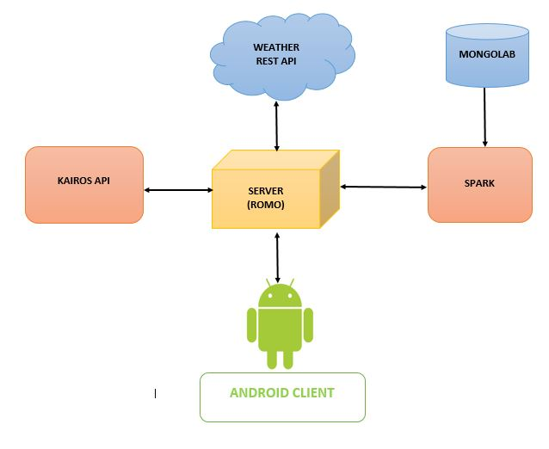

**Fig:** Architecture of Project

**4. SYSTEM FEATURES**

Technologies used to develop the application:

1. Development Machine: OS X
2. Device: iPhone 5s
3. Operating System: iOS
4. Robot: Romo
5. Back end: Apache Spark

The ten features which we have implemented are:

1. Buddy can recognise the household objects, which we have trained it using spark and announce the user.
2. Buddy can recommend books to the users using mongolab.
3. Buddy can wake-up the user by pre-set alarm by recognising his/her face.
4. Buddy can also make video calling by voice control.
5. Buddy can ask buddy to call or message friends or family by voice control.
6. Buddy can train the Buddy with faces of friends and family such that they are greeted next time.
7. Buddy can give the weather alerts of any city the user wants to know about.
8. Buddy can control its speed based on the terrain which it is moving.
9. Buddy’s movement can be controlled using the android client gesture.
10. Buddy’s motion can be controlled using voice or text input from android client or ios device.

**5. IMPLEMENTATION DETAILS**

To make disabled people’s life easier we have introduced Romo with Voice based user interface where the user can give all his commands to Romo just by his voice.

**a. Voice based control with peer-peer communication**

We have made easy for disabled people to interact with Romo by providing Peer-Peer communication between the Android client and the Robo. User can give his commands to Robo through client without personally reaching to the Romo. User can play with the Romo by directing its motion with his input commands like ‘GO’, ‘STOP’, ‘LEFT’, ‘RIGHT’. For example, when user gives input command as ‘GO’ the Romo should start going forward until it receives ‘STOP’ command. Similarly Robo moves to ‘LEFT’ when it receives ‘LEFT’ command.

**b. Reflecting Emotions**

Romo face on user interface reflects the emotions as provided by the user. When user gives input as ‘SMILE’ Romo smiles. Similarly it can show different emotions such as CRY, FEAR, SLEEPY and ANGRY.

**c. SMS & Video Conference**

User can ask Romo to send text messages to his friends by providing input via android client. Romo can also make video conference calls where user needs to announce the Contact name of the person whom he wants to make a call to. In this way Romo helps blind people to contact their friends easily via mobile.

**d. Color Detection**

Romo helps user in pedestrian crossing based on the traffic signal. When signal goes green Romo starts moving. In the same manner when the signal is in red it detects the red colour and stops. We have implemented this feature in order to help the visually impaired person.

e. **Alarms people about their duties**

User can set a reminder about the event/task of their daily activities or birthday events in the Robo. Now Robo will alert/alarm the people about the event/task on the input time set.

**f. Gesture recognition**

By using the information of coordinates produced by accelerometer our Robo can detect the gesture from mobile movement and will move accordingly. That is if the client moves the controller containing the accelerometer sensor to right then our Robo moves to right. In the same way it moves accordingly for the other three gestures - left, forward, backward.

**g. Controlling Robo velocity**

Using the change in Gyroscope data of the robot we have controlled the velocity of the Romo movement. Here Robo also changes its expression along with speed change.

**h. Interactive Session with NLP**

We can have an interactive session with Romo, we implemented NLP techniques with a set of Question & Answers in achieving this. This is to have a conversation with Romo when the user gets bored.

**i. Weather update**

Disabled person can check for weather condition of the place he is going to visit. User gives input ‘weather’ in speech and then Romo asks the person to give city name, which user is interested in knowing the weather condition. Now once user gives city name Romo replies with minimum and maximum weather conditions of the city for the same day, here Romo is crawling the weather information from the Google Weather API.

**j. Face Detection**

When a visitor enters the house of a blind person, Romo captures the face of the visitor and if the person visited is known that means already registered in Romo’s brain it greets the person with his name else it categorises him under intruder list. To achieve this we have trained Romo with few user’s face registering them with their names. When Romo sees the trained person it greets him, for example ‘Hi Ramya! How are you doing?’

This feature helps to alert the visually disabled person when any intruder arrives.

**k. Book recommendation (Full work-flow)**

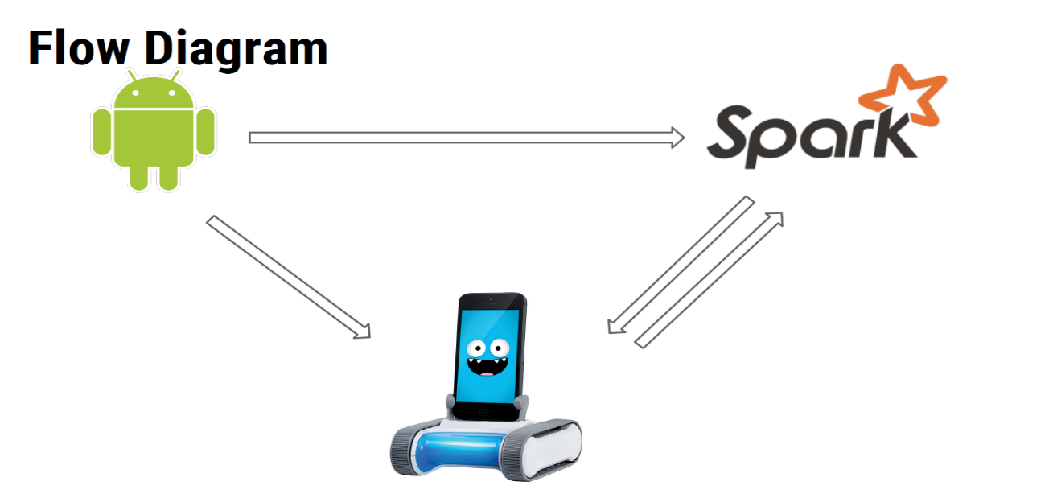 Romo can recommend books for disabled person based on his gender, age, and top ratings of books. We used MongoLab for storing book dataset. In Spark-Intellij IDEA books based on input gender, age and ratings are retrieved from whole dataset. Server is integrated with Spark, user uses Android client in connecting to Server. Finally list of books are recommended for the user.

Fig: Full work flow

**l. Image Classification**

Romo is trained to identify an image using Spark programming language. Here data set is stored in Spark provided by Intellij IDEA. First in training we take any object and its features are processed by feature vectors, classified using clustering algorithms and labeled as under Object name. Now when the object is placed in front of Robo it will capture image of the object and from trained Spark dataset it identifies the object and announces what the object is.

**6. RESULTS**

We have discussed all the features of Robo developed for helping disabled people. Below are the screenshots of results.

**a. Peer-Peer Communication**

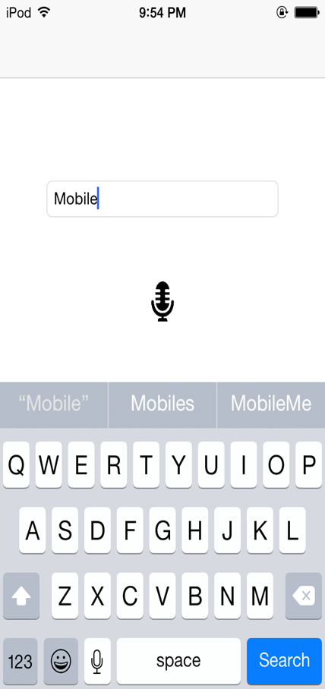

**b. Emotion Reflection of ‘SMILE’**



**c. Alarming/Reminding user**

When Alarm is set and Robo waiting to remind the user



When Robo alarms the user

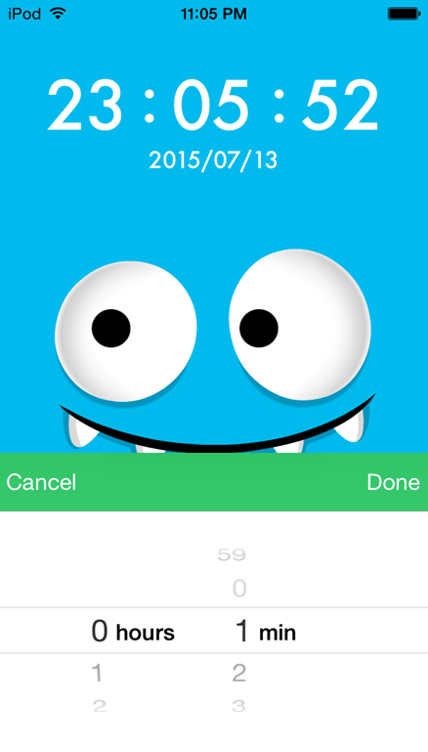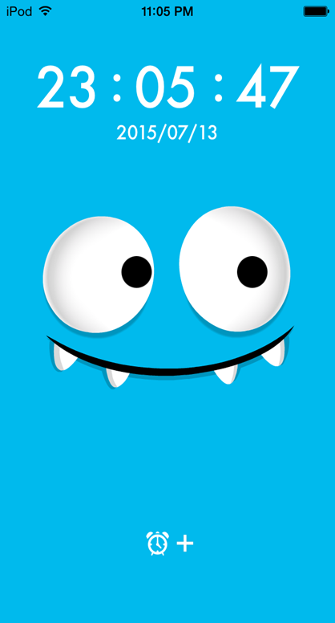

**d. Weather Update**

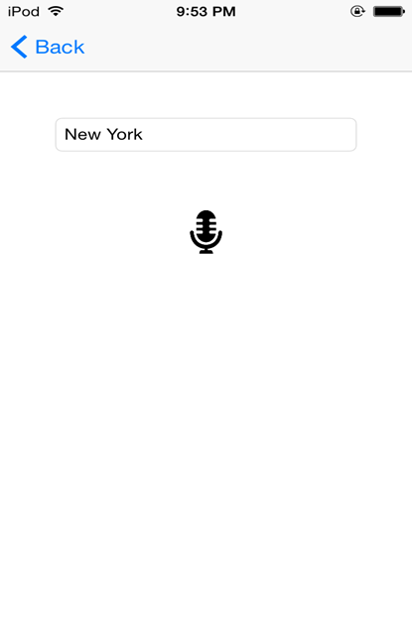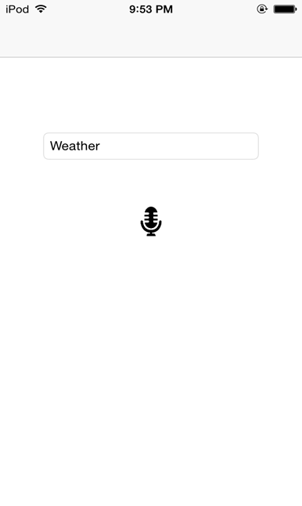

**e. Face detection**

While training the robo for a user

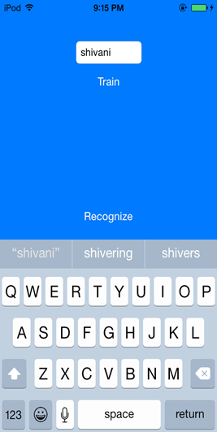

When Robo is recognizing the user once after the training is completed.

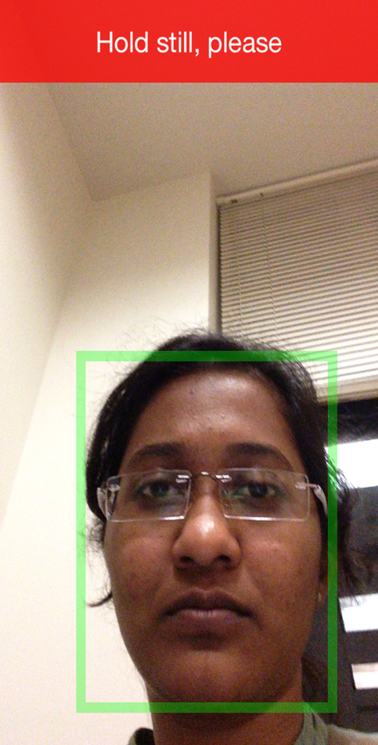

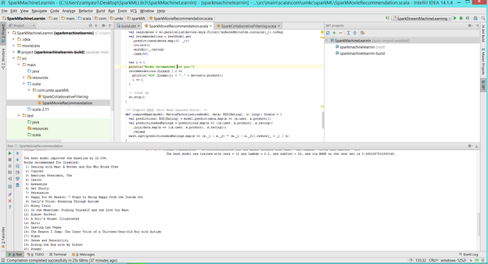**f. Book Recommendation in Spark**

**g. Image classification in Spark**

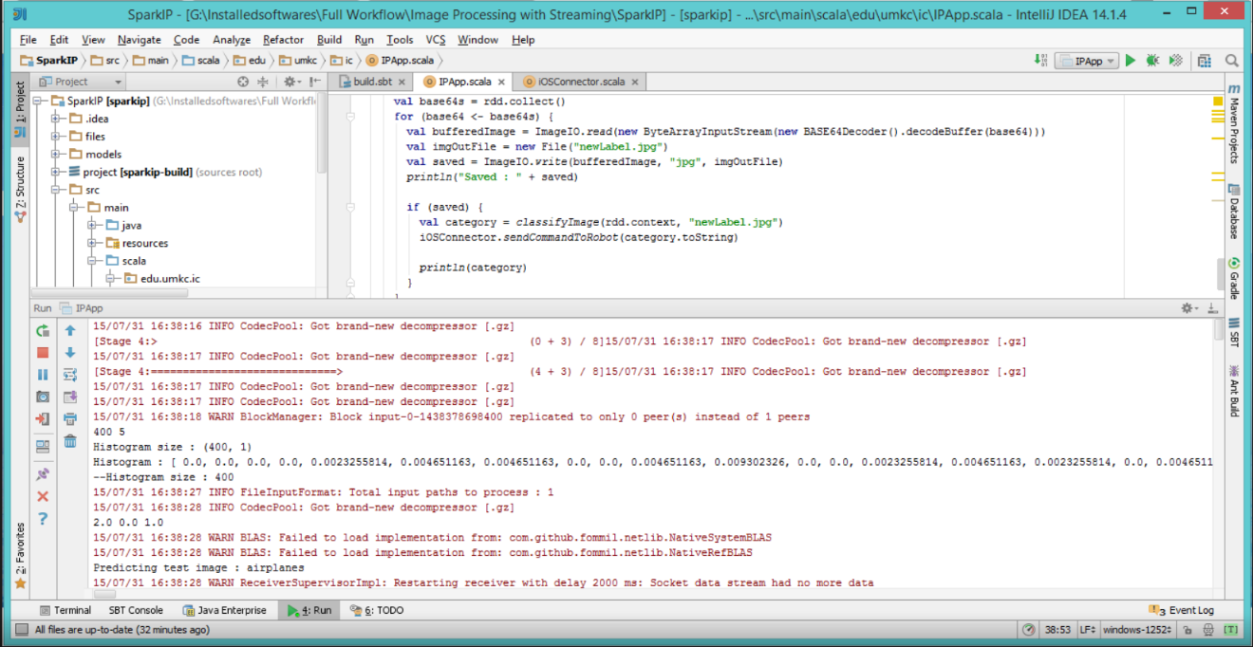

**For more result please check in this video Link:**

<https://www.youtube.com/watch?v=OtlAxwQLxco&feature=youtu.be>

**7. CONCLUSION/FUTURE WORK**

The devices available today for the visually impaired people are not meeting all the requirements they needed. So we have developed a robo called Buddy which can stay with him/her and entertain and help them with their day to day needs.

Here are the few add-ons that we have decided to work in future to our existing Buddy application:

1. Build optical character recognition for reading the sign boards.
2. Build Robo which can read out books in all languages for the user in an interactive fashion in order to improve their knowledge.
3. Build Robo which can recommend Books and also provide E-books details for the same list.
4. Build a device that can link the user to Buddy, to help Buddy move along with the user automatically.

**8. REFERENCES**

[1]Zaharia, Matei, et al. "Spark: cluster computing with working sets."Proceedings of the 2nd USENIX conference on Hot topics in cloud computing. Vol. 10. 2010.

<http://www.cs.berkeley.edu/~matei/papers/2010/hotcloud_spark.pdf>

[2]Zaharia, Matei, et al. "Resilient distributed datasets: A fault-tolerant abstraction for in-memory cluster computing." Proceedings of the 9th USENIX conference on Networked Systems Design and Implementation. USENIX Association, 2012.

<https://www.usenix.org/system/files/conference/nsdi12/nsdi12-final138.pdf>

[3]Holden Karau, Andy Kowinski, Patrick Wendell & Matei Zaharia. “Learning spark” : Introductory book for running spark.

<https://www.safaribooksonline.com/library/view/learning-spark/9781449359034/ch01.html>

[4]<https://developer.apple.com/library/ios/referencelibrary/GettingStarted/RoadMapiOS/FirstTutorial.html>